DJA SEBASTIAO

*Hogenbanweg 65C, 3112 CG Schiedam / +31(0)652416848 / d.g.m.sebastiao@gmail.com*

*www.linkedin.com/in/dja-g-m-sebastiao-66a87899*

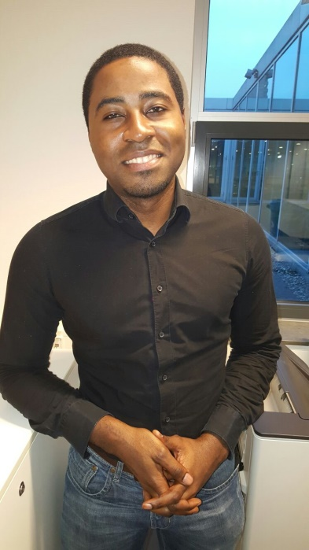I consider myself a modest and easy-going person, who enjoys getting things done. With a high level of determination and perseverance. I take on challenges and solve problems. I’m growth oriented: I like discovering & learning new things. My goal is creating value for others, and leaving a positive and lasting impression. People view me as helpful, sympathetic, full of humor and easy to talk to.

After defending my BSc dissertation, the thesis committee recognized and valued my strong analytical ability, and awarded me a grade of 9 out of 10. Ever since, I’ve applied this ability in the workplace; getting to the core of any problem/challenge and applying effective solutions.

# SKILLS

Analytical Quantitative & qualitative analysis, statistical analysis, SPSS (Jr. / beginner level), Stata (beginner).

Languages Fluent in: English (verbal & in writing), Dutch (verbal & in writing).

People Coaching / guidance, leadership, motivating, teamwork.

Policy Policymaking, -advisory, strategic thinking, logistics, LEAN & Agile.

Self Working / performing under pressure, self-motivated, problem-solving, adaptive & flexible.

Software Warehouse Management, Solidis, Denodo, SAP BusinessObjects

Programming Python, SQL, HTML, Powershell, VQL.

Office Tools Microsoft OS, Excel, MS Word, PowerPoint.

# WORK HISTORY

08. 2018 - present Erasmus MC – Rotterdam, ZH

**Technical Application Manager & Junior Architect.**

* My main role is to manage DWH-applications, such as; Denodo, BusinessObjects, SQL Server, etc. I manage performance, installing & upgrading various servers, solving various application issues.
* As Junior Architect, I’ve been specializing in the Denodo Solution Architecture. This involves streamlining the overall structure of the Denodo implementation and solving issues regarding Data Virtualization.

08. 2018 - present Medicine For Business – Rotterdam, ZH

**IT-Consultant & Application Manager.**

* Working as an consultant in other firms. Currently in the EMC CCBI as and   
  Application Manager & Junior Architecture.
* Functioning as a technical advisor in various projects, including Power BI and Wikimedia.
* Junior (IT-)consultant & project team-member in various projects.

06. 2017 – 08. 2018 Zegro – Rotterdam, ZH

**Team Leader**

* Safeguarding the continuity of the orderpick-process on a daily basis. On a daily basis making sure that deliveries/orders completed on time, and team members have the right tools for the job.
* Coordinate with fellow Team Leaders; locate & review possible process-related impediments, coordinate company-wide projects, participate in the hiring process.
* Developed and provided improvements towards the WMS-systems & orderpick-process. For example; I added additional functionalities to the user-interface, incorporated physical checklists in the digital environment.
* I coached, lead and motivated fellow team members, assuring they’re job-ready & skilled in their work.
* Started and participated in several improvement-projects, for example; I designed a more efficient work schedule, co-written the official work-safety manual, provided a workplace risk-analysis.

08. 2009 – present AHOLd europe (albert heijn) – Pijnacker, ZH

Allround Warehouse Worker

* As an operational worker inside the AHOLD warehouse, these are the core tasks: preparing orders, loading & unloading products, moving to storage, etc.
* Warehouse First Responder (BHV); an additional role as of the “Risico Inventarisatie & Evaluatie” (RIE).

08. 2009 – 08. 2013 Erasmus-MC – Rotterdam, ZH

General Data Analyst

* Analyzing clinical datasets by means of Excel & SPSS: I performed basic statistical analysis, such as regression, correlation, measuring survivability.
* Advisory role regarding obtained data-analysis results; discussing the direction of research, data-limitations, etc.
* Frequent brainstorm sessions regarding research focus.

12.2011 – 07.2012 GGD-RR – Rotterdam, ZH

*Internship:* Project-secretary & Ass. Municipality Accountholder

* Assisting head-accountholder in writing yearly financial report.
* Procuring relevant data from the heads of department.
* Performing simple financial calculations using Excel.
* Participating in “Gezondheidslijn”-project as project-secretary.
* Forming an effective project-team, with aid of staff department.
* Establishing and maintaining contact with relevant parties.
* Arranging and preparing project meetings & coordinating diaries.
* (Co-)writing project reports.

06.2011 – 07.2016 R.S.C. Voorwaarts – Rotterdam, ZH

*Volunteer work:* B**oard member & Policy Advisor**

* Setting goals & discussing corresponding policies with the board.
* Discussing the organizational vision & forward strategy.
* Aided in website development and organizational branding.
* Advisory role on policy setting, implementation & evaluation.

2009 – 2011 bavo Groep Europoort – Rotterdam, ZH

Male Nurse **/ Attendant**

* Attending to patients with mental illnesses.
* Preparing meals, cleaning patients, serving medication.
* Attending healthmonitor meetings & knowledge transfers.

# EDUCATION

09.2015 – Present Healthcare economics (MSc)

* A study that focuses on the economics of healthcare, and provides the student with econometric analysis tools for healthcare.
* A focus on conducting quantitative research, with the emphasis on developing quantitative skills and concepts.
* Subjects: healthcare costs, population, medical technology, aging, etc.

09.2009 – 01.2015 Healthcare Sciences (BSc)

Healthcare, -Policy, -Economics & Law

* A broad study of all aspects of healthcare & health sciences.
* Focuses on science & conducting research.
* Quantitative statistical analysis & qualitative research.

2008 – 2009 Informatica

Vrije Universiteit Amsterdam

2007 – 2008 Healthcare Technologies (HBO)

Higher vocational (HBO) – Propaedeutic degree

2004 – 2007 Havo

Higher secondary (continued) education

2000 – 2004 vmbo

Pre-vocational education

# Goals / learning objectives

* Further improving (or refining) of my analytical abilities by conducting more research/analysis.
* Mastering a craft, program or system (and adding valuable contributions).
* Becoming a highly valued healthcare systems professional/expert.
* Continuing to improve my communication skills (incl. soft skills, inspiring, articulation, etc.).
* Contributing at the leading edge of tech & IT innovation in Healthcare. Developing/improving tools (and systems) that can help both the patient as well as the practitioner.

# Strenghts / Weaknesses

* Strengths: Adaptable, helpful, practical & solution-driven, driven, humorous, orderly & systematic, team player, accessible, devoted.
* Weaknesses: aversion to disappointing others, avoiding group-conflict, over-responsible, high standards / goals / expectations.

Motto I live by:

**“..underpromise & overdeliver..”**